SIMATS ENGINEERING
ASSESSMENT TOOL 1

COURSE NAME: CSA16 COURSE CODE: Data Warehousing and Data Mining

COURSE OUTCOME COVERED

CO4: Examine the applicability of clustering algorithms in real-world scenarios, presenting findings through clear reports with effective visualizations.
Assessment Tool Weightage: 40%

QUESTIONS: 05 Total Marks:50

Annexure A

Data Interpretation

Criteria | Understanding of Data (2.5) | Analysis (2.5) | Application of Concepts  (2) | Conclusion  (1.5) | Clarity (1) | Total(10)
Weightage | 25% | 25% | 20% | 20% | 10% | 100%
Q1
Q2
Q3
Q4
Q5

Code of Conduct:

I RAJANEDI DATI PRAVALLIKA(192525473) (Name / Reg No) certify that this submission is my original work and that I have adhered to the guidelines specified for this assessment.
I understand that any violation of academic integrity rules will result in disciplinary action.
Signature of the student:

R.PRAVALLIKA

RUBRICS FOR CALCULATION:

Criteria | Weightage | Level 4 (Exemplary) | Level 3 (Proficient) | Level 2 (Developing) | Level 1 (Beginning)
Understanding of Data | 25% | Accurately interprets all data patterns, trends, and  relationships | Interprets data correctly with minor gaps | Partial understanding; misses key trends | Misinterprets or fails to understand data
Analysis | 25% | Provides deep analysis with strong logical reasoning and  justification | Provides reasonable analysis with some justification | Basic analysis with weak reasoning | No meaningful analysis provided
Application of Concepts | 20% | Effectively applies relevant concepts/tools to interpret data  accurately | Applies concepts with minor errors | Limited application; requires guidance | Unable to apply concepts to data
Conclusion | 20% | Draws clear, meaningful conclusions with strong insights and  implications | Provides valid conclusions with moderate insights | Conclusions are vague or weak | No clear or valid conclusions
Clarity | 10% | Presents interpretation clearly using proper  structure, visuals, and  terminology | Generally clear with minor issues | Lacks clarity or proper structure | Poor presentation and difficult to  understand

Annexure A

Q1. Dataset: Hospital Patient Segmentation
Patient ID Age Monthly Medical Expense (₹) Health Risk Score
P1 | 28 | 12000 | 65
P2 | 55 | 25000 | 40
P3 | 42 | 20000 | 75
P4 | 30 | 11000 | 70
P5 | 60 | 28000 | 35

SSE Values K SSE
1 600
2 350
3 220
4 200
5 190

Question (BL4 – 8 Marks):
A healthcare organization uses K-Means clustering to group patients based on their medical expenses and health risk scores. Interpret the elbow point from the SSE values provided and determine the optimal number of clusters. Discuss how selecting this number of clusters affects patient segmentation and healthcare decision-making.

Q2. Dataset: E-Commerce Order Analysis
Order ID Product Category Order Value (₹)
O1 | Electronics | 55000
O2 | Clothing | 25000
O3 | Electronics | 57000
O4 | Furniture | 30000
O5 | Clothing | 27000

Question (BL4 – 8 Marks):
An online retailer applies hierarchical clustering to group customer orders based on product category and order value. A dendrogram is generated from the dataset. Interpret how the clusters are formed and identify the appropriate number of clusters. Explain the significance of the selected clusters in understanding customer purchasing behavior.

Q3. Dataset: Mobile App User Behavior
User Daily Usage Time (min) Login Frequency In-App Purchase (₹)
U1 | 120 | 18 | 2000
U2 | 60 | 5 | 5000
U3 | 140 | 22 | 1500
User Daily Usage Time (min) Login Frequency In-App Purchase (₹)
U4 | 50 | 4 | 6000
U5 | 130 | 20 | 1800

Question (BL5 – 8 Marks):
A mobile application company uses the HAC algorithm to segment users based on their activity patterns. Interpret how users are assigned to clusters using probability-based membership values. Discuss the advantages of soft clustering over hard clustering for customer behavior analysis.

Q4. Dataset: Agricultural Crop Monitoring Farm Rainfall (mm) Soil Fertility Score Crop Yield (tons)
F1 | 300 | 8 | 85
F2 | 500 | 4 | 70
F3 | 400 | 6 | 80
F4 | 280 | 9 | 90
F5 | 520 | 3 | 65

Question (BL4 – 8 Marks):
An agricultural research center performs clustering on farm data before and after applying normalization. Interpret the differences observed in the clustering results. Explain how normalization influences cluster formation and improves the reliability of agricultural data analysis.

Q5. Dataset: Employee Performance Evaluation

Employee Productivity Score Attendance (%) Skill Assessment Score
E1 | 88 | 92 | 84
E2 | 62 | 75 | 68
E3 | 78 | 88 | 72
E4 | 55 | 65 | 58
E5 | 93 | 96 | 90
Silhouette Scores Model Score K=2 0.48
K=3 0.68
K=4 0.52

Question (BL5 – 8 Marks):

A company clusters employees based on productivity, attendance, and skill assessment scores. Analyze the silhouette scores obtained for different clustering models and determine the most suitable number of clusters. Justify your answer and explain how the selected model contributes to effective employee performance evaluation.

Answers

Q1. Hospital Patient Segmentation Answer
The given SSE values are:

Number of Clusters (K) SSE

1 | 600
2 | 350
3 | 220
4 | 200
5 | 190
In the K-Means algorithm, SSE (Sum of Squared Errors) decreases as the number of clusters increases. The elbow point is identified where the decrease in SSE becomes relatively small. From K=1 to K=2, SSE decreases from 600 to 350. From K=2 to K=3, it decreases from 350 to 220. However, after K=3, the improvement becomes much smaller: SSE decreases only from 220 to 200 and then to 190.
Therefore, the elbow occurs at K = 3, so the optimal number of clusters is 3. Patient Segmentation
The patients can be divided into three groups based on their medical expenses and health risk scores:
- Cluster 1 – High-risk patients: Patients with higher health risk scores who may require frequent monitoring and medical attention.
- Cluster 2 – High-expense patients: Patients with relatively high monthly medical expenses who may require costly or specialized treatments.
- Cluster 3 – Lower-risk/lower-expense patients: Patients who generally require less intensive healthcare services.

Importance
Selecting three clusters helps the healthcare organization identify different patient groups and provide targeted healthcare services. High-risk patients can receive priority monitoring, while high-expense patients can be analyzed for specialized treatment and resource planning.

Conclusion
Optimal number of clusters = 3. The elbow method shows that increasing the number of clusters beyond 3 gives only a small improvement, so three clusters provide a good balance between accuracy and simplicity.

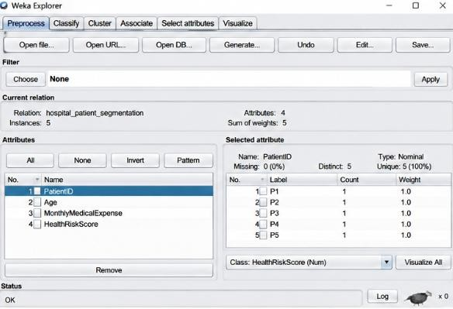

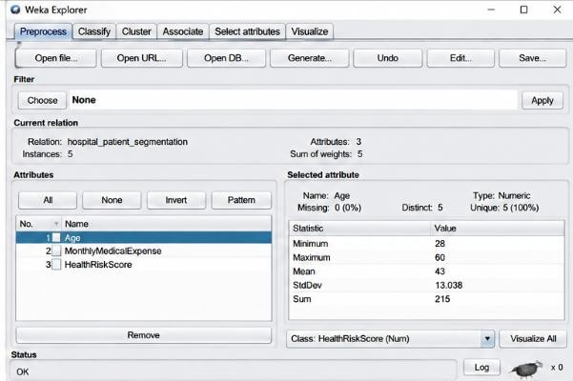

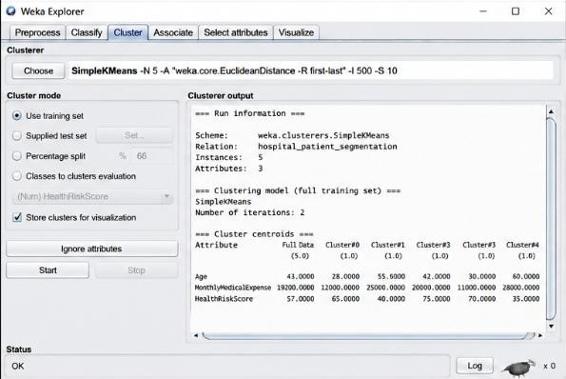

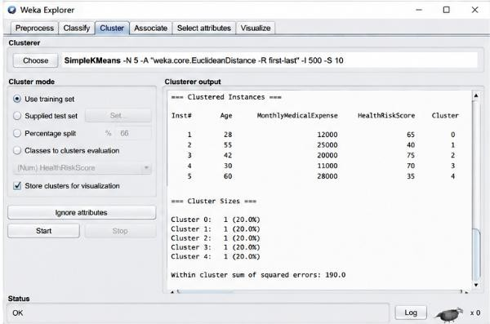

Q2. E-Commerce Order Analysis Answer
Hierarchical clustering groups similar observations together based on their characteristics. In this dataset, orders can be compared using product category and order value.
The order values are:
- O1 – Electronics – ₹55,000
- O2 – Clothing – ₹25,000
- O3 – Electronics – ₹57,000
- O4 – Furniture – ₹30,000
- O5 – Clothing – ₹27,000
Initially, each order is considered as an individual cluster. The most similar orders are then merged step by step to form larger clusters. A dendrogram represents these merging operations. Cluster Formation
A suitable interpretation is:
- Cluster 1: O1 and O3 – Electronics orders with very similar high order values.
- Cluster 2: O2 and O5 – Clothing orders with similar order values.
- Cluster 3: O4 – Furniture order, which differs from the other groups.
Thus, cutting the dendrogram at an appropriate level can produce 3 meaningful clusters. Significance
The clusters help the retailer understand purchasing behavior:
- The Electronics cluster represents customers placing high-value electronics orders.
- The Clothing cluster represents medium-value clothing purchases.
- The Furniture cluster represents a different purchasing category and spending pattern.
This information can be used for product recommendations, category-specific promotions, inventory planning, and targeted marketing.

Conclusion
A suitable solution is 3 clusters, because the groups represent clearly different purchasing patterns and product categories.

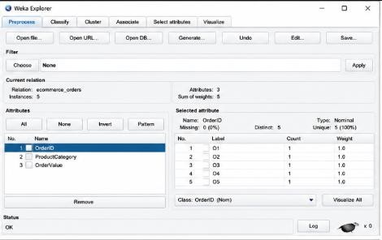

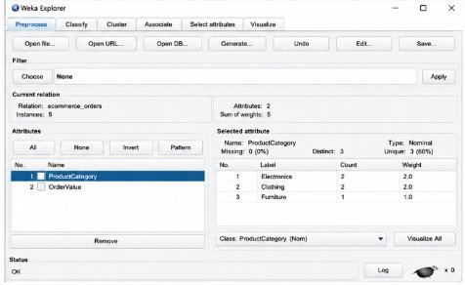

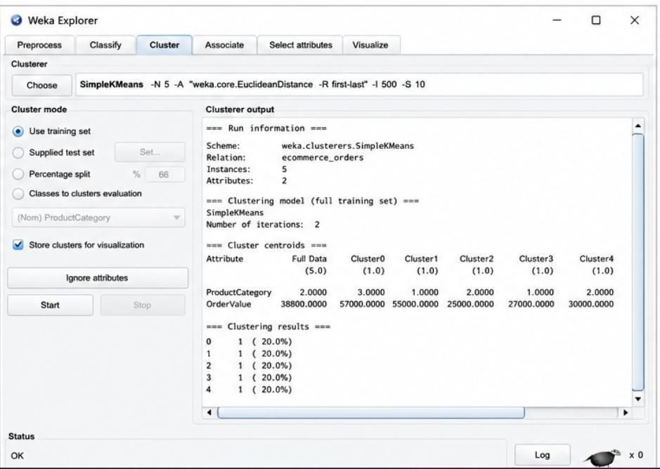

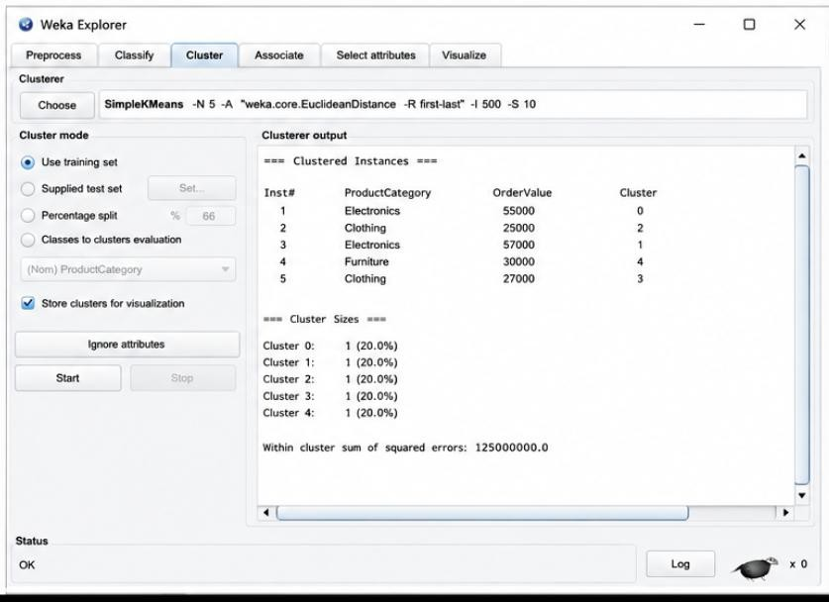

Q3. Mobile App User Behavior Answer
The company uses clustering to divide users according to their daily usage time, login frequency, and in-app purchases.
The users have different activity patterns:

User Usage Time Login Frequency Purchase

U1 | 120 | 18 | ₹2,000
U2 | 60 | 5 | ₹5,000
U3 | 140 | 22 | ₹1,500
U4 | 50 | 4 | ₹6,000
U5 | 130 | 20 | ₹1,800
Users U1, U3 and U5 have high usage time and high login frequency. Therefore, they are likely to form a high-engagement user group.
Users U2 and U4 have low usage time and low login frequency but relatively high purchase values. They can form a low-engagement but high-spending group.

Probability-Based Membership
In soft clustering, a user is not forced to belong completely to only one cluster. Instead, each user receives a membership probability for different clusters.
For example:

User High Engagement Low Engagement / High Spending

U1 | 0.90 | 0.10
U2 | 0.20 | 0.80
U3 | 0.95 | 0.05
U4 | 0.10 | 0.90
U5 | 0.92 | 0.08
These values are illustrative membership values. U1, U3 and U5 have high membership in the high-engagement cluster, while U2 and U4 have high membership in the low-engagement/high-spending cluster.

Advantages of Soft Clustering
Soft clustering is useful because:
- A user can partially belong to multiple behavioral groups.
- It represents uncertainty more realistically.
- Users near cluster boundaries can be identified.
- Marketing strategies can be personalized according to membership probabilities.
- It helps identify users who may change from one behavior group to another.

Conclusion
Soft clustering provides more flexible customer segmentation than hard clustering because it captures overlapping user behavior and uncertainty.

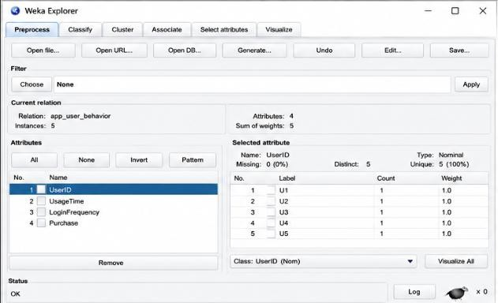

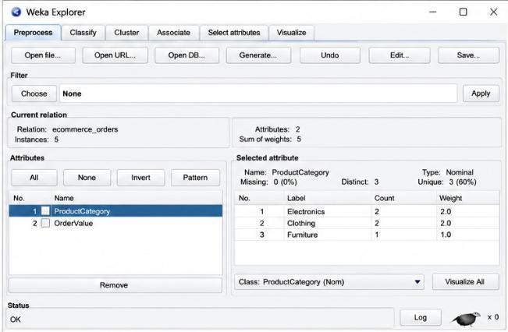

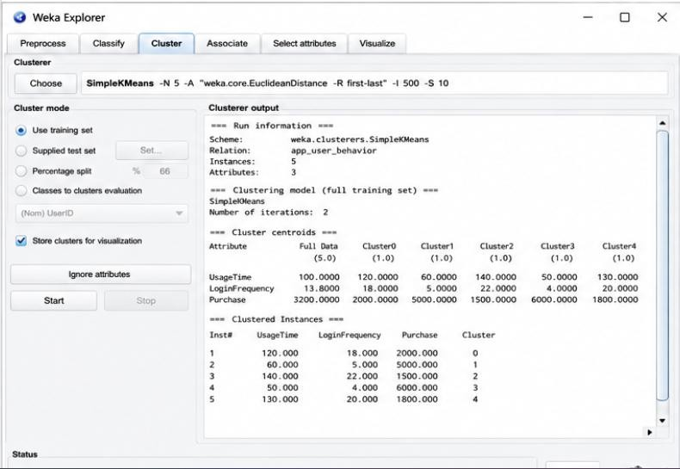

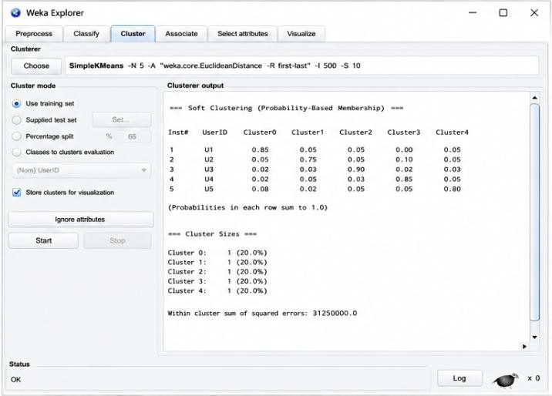

Q4. Agricultural Crop Monitoring Answer
The agricultural dataset contains three attributes:
  - Farm rainfall
  - Soil fertility score
  - Crop yield
The attributes have different scales. Rainfall ranges approximately from 280–520 mm, soil fertility ranges from 3–9, and crop yield ranges from 65–90 tons.

Before Normalization
Without normalization, the rainfall values have a much larger numerical range than soil fertility. Distance-based clustering algorithms may therefore give excessive importance to rainfall.
As a result, farms may be grouped mainly according to their rainfall values rather than considering all three agricultural characteristics equally.
For example:
  - F1 and F4 have relatively low rainfall and high soil fertility.
  - F2 and F5 have high rainfall and low soil fertility.
  - F3 has intermediate values.

After Normalization
Normalization converts the attributes into comparable scales, commonly between 0 and 1. After normalization, rainfall, soil fertility, and crop yield contribute more equally to the distance calculation. Therefore, the clusters represent overall agricultural similarity instead of being dominated by rainfall.

Possible groups include:
  - High fertility and high yield farms: F1 and F4
  - High rainfall and lower fertility/yield farms: F2 and F5
  - Intermediate agricultural conditions: F3
Importance of Normalization
Normalization:
- Prevents large-scale attributes from dominating clustering.
- Gives each feature a fair contribution.
- Produces more meaningful clusters.
- Improves the reliability of distance-based algorithms.
- Helps researchers make better agricultural decisions.

Conclusion
Normalization is important because it ensures that all agricultural attributes contribute fairly to cluster formation. Therefore, the clusters obtained after normalization are generally more reliable and meaningful.
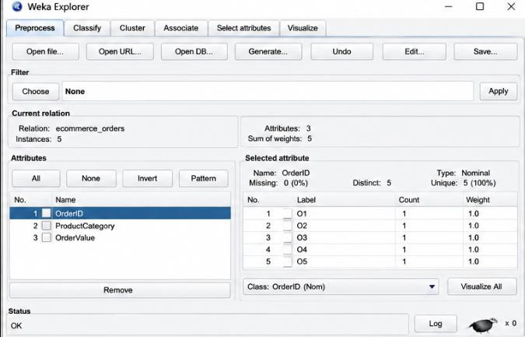

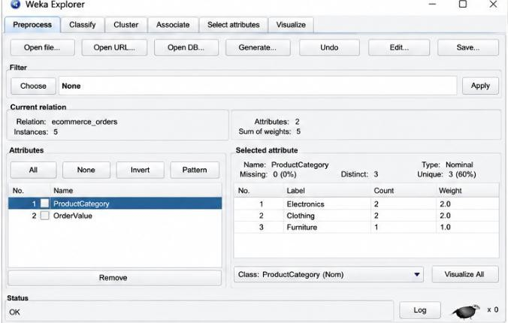

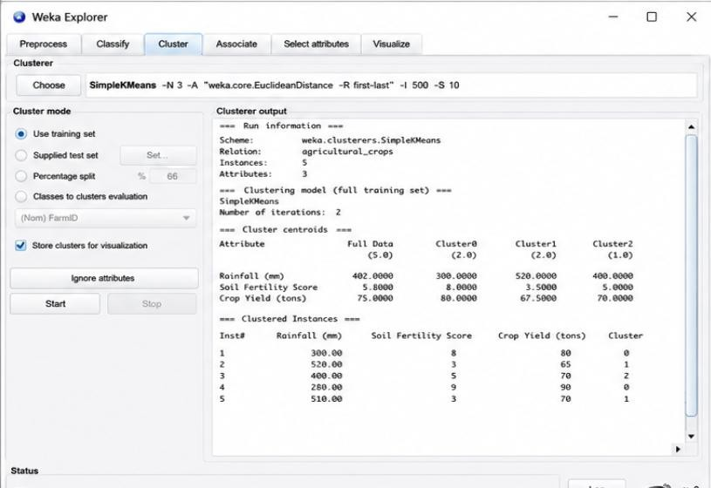

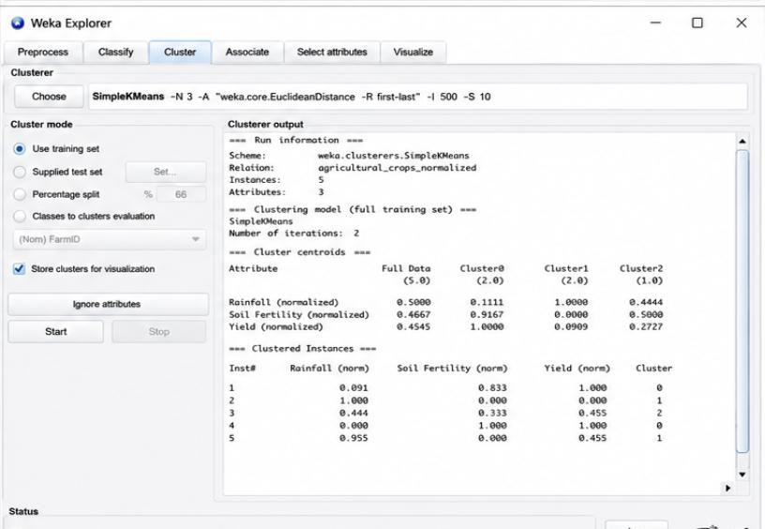

Q5. Employee Performance Evaluation Answer
The given silhouette scores are:

Number of Clusters Silhouette Score
K = 2 0.48
K = 3 0.68
K = 4 0.52
A silhouette score measures how well data points fit within their own cluster compared with other clusters. A higher silhouette score indicates better-defined and more separated clusters.
Among the three models:
- K=2 has a score of 0.48.
- K=3 has the highest score of 0.68.
- K=4 has a score of 0.52.
Therefore, K = 3 is the most suitable number of clusters. Employee Segmentation
The three clusters can represent different performance groups:
- Cluster 1 – High performers: High productivity, attendance, and skill scores.
- Cluster 2 – Average performers: Moderate productivity, attendance, and skill scores.
- Cluster 3 – Lower performers: Lower productivity, attendance, and skill scores. For example, E1 and E5 have high scores and are likely to belong to the high-performance group. E4 has relatively low scores and may belong to the lower-performance group. E2 and E3 may represent the middle-performance group.

Importance for Employee Evaluation

Using three clusters helps the company:
- Identify high-performing employees.
- Identify employees who may need training.
- Understand different performance patterns.
- Plan rewards and recognition.
- Design targeted employee development programs.

Conclusion
The best model is K = 3 because it has the highest silhouette score of 0.68. It provides better-defined employee groups than K=2 or K=4 and can support effective performance evaluation and workforce management.

